A REPORT
ON
FAST ATTENDANCE ENCODING SYSTEM USING BITWISE OPERATIONS
BY
Keerthana AP24110010298
Jasmitha AP24110010299
Madhulika AP24110010302
Likhitha Ganga AP24110010308
Hamsavalli AP24110010516
Gowmika AP24110010527
PREPARED IN THE PARTIAL FULFILLMENT OF THE
PROJECT BASED LEARNING OF COURSE CSE 201



Acknowledgement
I would like to express my sincere gratitude to my faculty for giving me the opportunity to work on this project, “Fast Attendance Encoding System using Bitwise Operations.”
This project helped me gain practical knowledge of bit manipulation and the use of bitwise operators in C++ programming.
I am thankful for the guidance, support, and encouragement provided throughout the project. I also extend my thanks to my friends and classmates for their suggestions and cooperation. Finally, I would like to thank my family for their constant motivation and support which helped me successfully complete this work.

Abstract
In educational institutions, maintaining and processing attendance for large classrooms can be memory-consuming and inefficient if traditional data structures are used, such as arrays of integers or strings. This project proposes a memory-efficient attendance management system that uses bit manipulation to store and process attendance information.
Each student’s attendance (Present/Absent) is represented using a single bit in an unsigned integer variable. Bitwise operators such as AND, OR, NOT, and bit shifting are used to:
- Mark attendance
- Check attendance of a specific roll number
- Replace attendance
- Count the total number of present and absent students
The system significantly reduces memory usage and demonstrates the practical application of bitwise operations in real-world scenarios like classroom attendance management.

CONTEXT

- Introduction------------------------------- 5
- Objective----------------------------------- 6
- Problem Statement---------------------- 6
- Methodology------------------------------ 7
- Implementation Details---------------- 8
- Implementation-------------------------- 9
- Outcomes----------------------------------- 14
- Output--------------------------------------- 16
- Advantages--------------------------------- 18
10.Conclusion----------------------------------- 18

Introduction
Bit Manipulation is a powerful low-level programming concept where we operate directly on bits (0s and 1s). Using this concept, we can represent the attendance of up to 32 students (for a 32-bit unsigned int) using just 4 bytes of memory. Attendance management is an essential activity in schools, colleges, and organizations. Traditional methods use registers, Excel sheets, or arrays where one student may take multiple bytes (e.g., storing ‘P’/‘A’ or strings). While this works, it is not optimized for systems where memory is limited or when the number of students is very large.

In this project:
- Each student (each roll number) maps to one bit in an integer.
- Value of bit = 1 → Present
- Value of bit = 0 → Absent
This project not only addresses memory efficiency but also helps understand the application of bitwise operators in problem solving.

Objective
- To store attendance of a classroom using minimum memory.
- To use bitwise operators for:
  - Marking Present/Absent
  - Checking a student’s attendance
  - Replacing attendance
  - Counting present and absent students

Problem Statement
Conventional attendance storage for a class of N students uses one variable per student (like char, int, or string). This leads to unnecessary memory usage, especially when we only need to store two states: Present or Absent.
Problem:
How can we store the attendance of multiple students using minimal memory while still allowing fast operations like:
- Marking attendance
- Checking attendance of any roll number
- Counting present and absent students
- Modifying attendance later
Proposed Solution:
Use a single unsigned int where each bit represents the attendance of one student.

Methodology
Step-1: Use Bit Position = Roll Number
Roll no. → Bit position
Example:
Roll 1 → Bit 0
Roll 2 → Bit 1
Roll 3 → Bit 2
Step-2: Set Bit (Mark Present)
attendance |= (1 << roll);
This sets the bit to 1.
Step-3: Clear Bit (Mark Absent)
attendance &= ~(1 << roll);
This sets the bit to 0.
Step-4: Check Attendance
if (attendance & (1 << roll))
// Present
else
// Absent
Step-5: Count Present Students.
while(temp) {
temp &= (temp - 1);
count++;
}
This counts number of 1 bits

Implementation Details
Bitwise Operators Used
- << (Left Shift)
- | (Bitwise OR)
- & (Bitwise AND)
- ~ (Bitwise NOT)
Key Operations
- Mark Present: attendance |= (1 << roll);
- Mark Absent: attendance &= ~(1 << roll);
- Check Attendance: attendance & (1 << roll)
- Count Present: Loop using temp &= (temp - 1)

Implementation
#include <iostream>
using namespace std;

unsigned int attendance = 0; // bit storage for attendance

// Mark attendance
void markAttendance(int roll, char status) {
if (status == 'P' || status == 'p') {
attendance |= (1 << roll); // set bit
}
else if (status == 'A' || status == 'a') {
attendance &= ~(1 << roll); // clear bit
}
else {
cout << "Invalid entry! Use P/p or A/a.\n";
}
}

// Count present students
int countPresent() {
int count = 0;
unsigned int temp = attendance;

while (temp) {
temp &= (temp - 1); // removes the lowest set bit
count++;
}
return count;
}

int main() {
int totalStudents, roll, choice;
char status;

cout << "Enter number of students (max 32): ";
cin >> totalStudents;

if (totalStudents > 32 || totalStudents < 1) {
cout << "Invalid number of students!\n";
return 0;
}

cout << "\n------ Mark Attendance ------\n";

for (roll = 1; roll <= totalStudents; roll++) {
cout << "Roll " << roll << " → Enter P/p for Present or A/a for Absent: ";
cin >> status;
markAttendance(roll, status);
}

// Menu for operations
while (true) {
cout << "\n========== MENU ==========\n";
cout << "1. Count Present Students\n";
cout << "2. Count Absent Students\n";
cout << "3. Check Attendance of a Roll Number\n";
cout << "4. Show Bits Used\n";
cout << "5. Replace Attendance for a Roll No\n";
cout << "6. Exit\n";
cout << "Enter choice: ";
cin >> choice;

switch (choice) {

case 1:
cout << "Total Present: " << countPresent() << "\n";
break;

case 2:
cout << "Total Absent: " << totalStudents - countPresent() << "\n";
break;

case 3:
cout << "Enter Roll Number: ";
cin >> roll;

if (roll >= 1 && roll <= totalStudents) {
if (attendance & (1 << roll))
cout << "Roll " << roll << " is PRESENT.\n";
else
cout << "Roll " << roll << " is ABSENT.\n";
} else {
cout << "Invalid roll number!\n";
}
break;

case 4:
cout << "Total Bits Used for Attendance = " << totalStudents << " bits\n";
break;

case 5:
cout << "Enter Roll Number to Replace: ";
cin >> roll;

if (roll >= 1 && roll <= totalStudents) {
cout << "Enter new status (P/p or A/a): ";
cin >> status;
markAttendance(roll, status);
cout << "Attendance updated for Roll " << roll << ".\n";
}
else {
cout << "Invalid roll number!\n";
}
break;

case 6:
cout << "Exiting program...\n";
return 0;

default:
cout << "Invalid option!\n";
}
}

return 0;
}

Outcomes

- Understood the concept of bit-level data representation.
- Learned how to store multiple student attendance values in just one integer variable.
- Implemented memory-efficient storage, using only 1 bit per student instead of 1 byte or more.
- Learned practical usage of bitwise operators
(<<, |, &, ~) in a real project.
- Successfully performed operations like:
✓ Mark Present
✓ Mark Absent
✓ Check attendance
✓ Toggle attendance
✓ Count total present and absent students
- Learned to create and use bit masks to access specific bits.
- Improved understanding of binary representation and left shift operations.
- Learned a fast method to count set bits using:
temp &= (temp - 1)
- Developed a simple menu-driven C++ program for real-life use.
- Gained knowledge on how compact data structures save memory in large systems.
- Demonstrated how bit operations make programs faster compared to array methods.
- Increased confidence in applying low-level programming concepts to real-world problems.
- Learned a technique that can be used in other applications like:
attendance tracking, permissions, flags, and digital storage.

Output
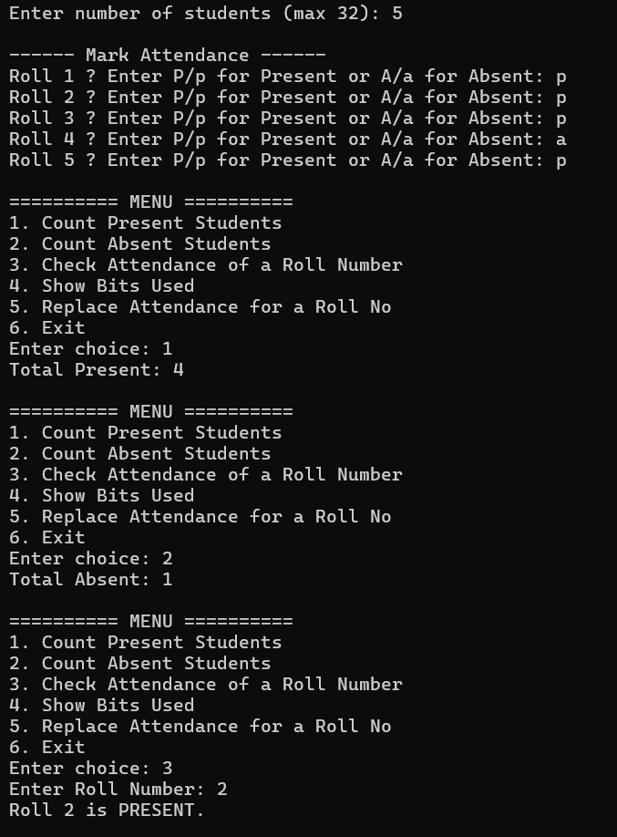

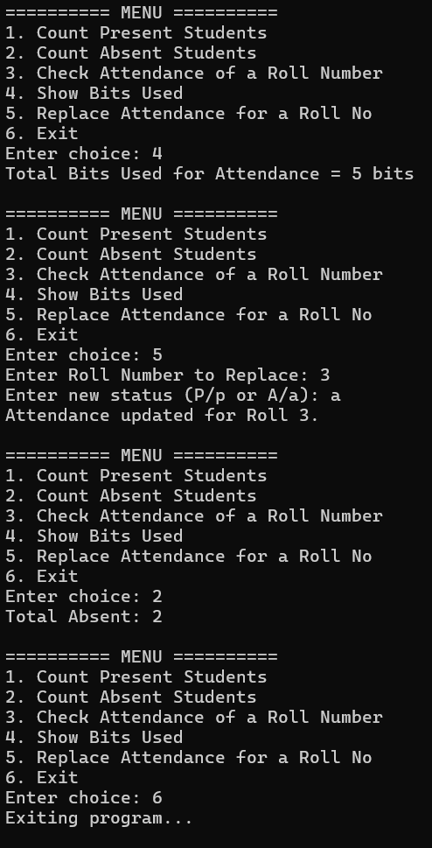
Advantages
- Very low memory usage
- Fast and efficient operations
- Simple implementation
- Useful for large classroom attendance systems
- Can be extended for other boolean storage tasks

Conclusion
This project shows how bitwise operations can be used to store and manage attendance in a very efficient way. Instead of using separate memory for each student, we used a single integer where each bit represents one student's attendance. Bit manipulation allowed us to quickly mark, check, and count present or absent students using very little memory.
By applying operators like shift, AND, OR, and NOT, we were able to perform all attendance operations easily and fast. The complete system works in just a few bytes, making it suitable for large classrooms and real-time applications.
Overall, the project helped in understanding how binary data and bitwise operations can solve real-life problems with simple logic and high performance. This technique can be extended to other areas such as record keeping, permissions, settings flags, and compact data storage.

